Due to recent revisions by EPA of the lead and copper rule we are required to perform an inventory of service line materials within our service area. The Water System Name needs your help to gather information about the plumbing entering your home. Following the steps below please examine the water supply pipe between the meter and your home and identify the pipe material. An online version of this form can be found here: <https://yourwatersystem.org/survey>

**1. Locate a drinking water line**

If you have easy access to the basement / crawl space, look for a pipe that enters the house through an outside wall or dig near your shutoff valve outside—this is your water line.

**2. Determine if the pipe is plastic or metal by looking at or tapping it.**

**3. If the pipe is metal, use a refrigerator magnet to check if it is magnetic.**

If a magnet sticks, the pipe is galvanized iron or steel.

**4. If it’s NOT magnetic, use a coin to gently scratch the pipe.**

If it scratches very easily and turns a shiny silver color, it’s lead.

If the pipe doesn’t scratch easily, has a copper color, and is not magnetic, it’s made of copper.

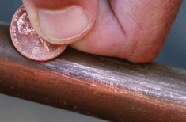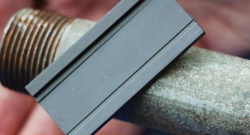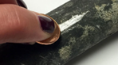

**(Please fill out Survey and Return with Your Bill Payment.)**

✂ ✂ ✂

Customer Name: _____________________________________________________________________

Address: __________________________________________ Installation Date: __________________

Material for Customer Service Line: (**Please Check One**)

☐ Plastic (PVC, Poly, Pex) ☐ Galvanized ☐ Copper

☐ Lead ☐ Lead-lined Galvanized ☐ Unknown

☐ Other - (Please Describe):__________________________________________________

Line Size (if known): ____________________________________________________________________

**Signature ________________________________________________ Date: _____________________

** By signature, I (Property Owner) certify that the information provided above is true and correct to the best of my knowledge.

# Form Instructions:

This form is intended to be a generic letter you can provide to your customers to identify their plumbing materials from the meter to the house / business. Due to complex formatting the document is protected to allow only changes to the highlighted fields and to replace the logo picture. Should you wish to unprotect the document the instructions are below. Please provide only the front page to your customers.

1. 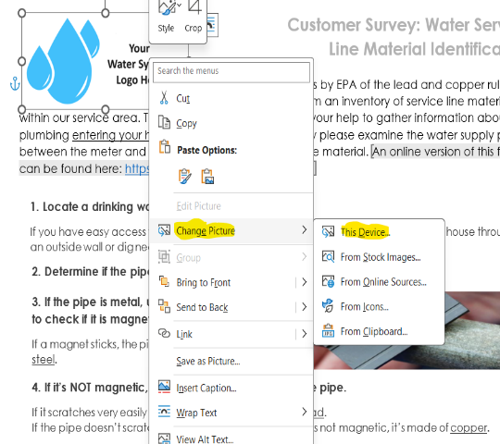Insert your Water System Logo or Text with Water System Name.
   1. To change picture, right click on “Water System Logo Here”, select change picture and click your source. This will open a dialogue box to allow you to find the picture you wish to insert.
   2. Resize as appropriate to fit the dimentions of your logo.
   3. A screenshot of a computer

      Description automatically generatedTo add text delete the picture and then go to the Insert tab and select Text Box on the ribbon.
2. Insert Your Water System Name in the highlighted field.

3. The statement about online form availability may be removed if not needed. If used, please make sure your website URL is entered correctly and works prior to mailing the letter.

To unprotect the document for editing, click on the “File” tab, then on “Info”, then “Protect Document” and finally “Restrict Editing”. This will open another window beside your document, at the bottom click on “Stop Protection”, you can then freely edit the document.

